Gustavo Henrique Pinto

Tipos de componentes de interface

- Abas

- Acordeão
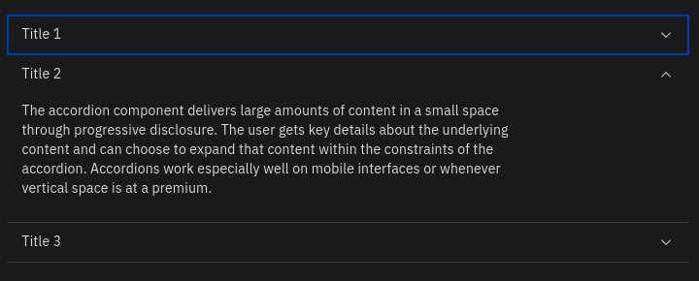
- Barra de progresso

- Botões

- Breadcrumbs
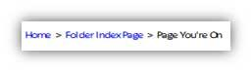
- Campos de data
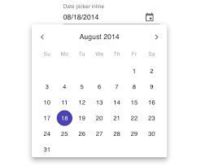
- Campos de texto
- Carrosel

- Checkboxes
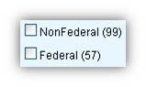
- Formulários
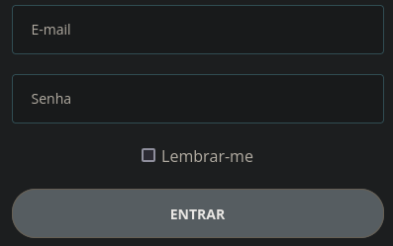
- Listas dropdown
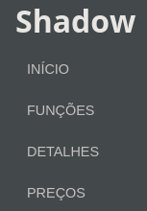
- Modais
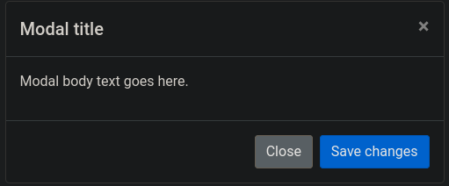
- Notificações
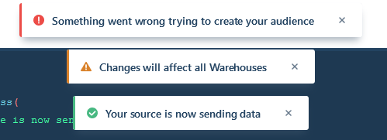
- Paginação

- Seletor
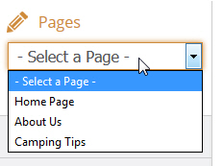
- Toggles
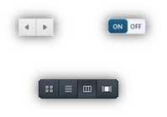
- Tooltips
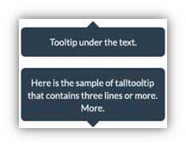
Bibliografia

- https://www.carbondesignsystem.com/
- https://careerfoundry.com/en/blog/ui-design/ui-element-glossary/
- https://www.usability.gov/how-to-and-tools/methods/user-interface-elements.html
- https://www.uxpin.com/studio/blog/user-interface-elements-every-designer-should-know/
- https://blog.logrocket.com/top-react-date-pickers-for-2021/
- https://getbootstrap.com/docs/4.0/components/modal/

